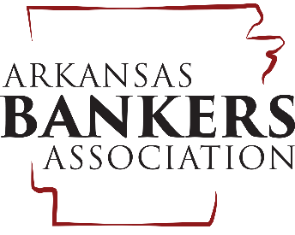
Arkansas Banker Association
1220 West Third Street
Little Rock, AR 72201
(501) 978-3603

Sample Employee Newsletter Article For Release Prior to October 5

[Bank Name] Encourages Employees to Vote this November

Are you registered to vote? Voter registration deadline in Arkansas (October 7) is rapidly approaching. People fail to vote for a lot of reasons—lack of awareness, apathy, confusion, or a belief that “my vote won’t make a difference.” [Bank Name] encourages all of our employees to make their voice heard this November, and we hope that “not being registered” won’t be the reason you don’t vote.
Registering to vote is easy! Just log on to the Arkansas Secretary of State website (www.sos.arkansas.gov) and complete the Arkansas’s voter registration application. You can also use this site to find out how to update your voter registration information, see district maps, and view proposed ballot issues.
Nearly 20,000 Arkansans, and 2.1 million Americans, are employed by the banking industry. United, our vote will make a difference in this year’s election. The cornerstone of our system is a government of the people; increased voter participation can and will improve how the system performs for each of us.

Sample Employee Newsletter Article For Release Prior to October 30

Take Care of Your Investment in the [City/County] Community
Employees to Vote on November 6

Did you know that there are more than 97,000 bank offices across the country? Banks support our communities, with a stake in the economic growth and vitality of small towns and large cities. Because [Bank Name] employees have so much invested in the [City/County] community, we encourage each of you to take part in next month’s elections.
The Arkansas General Election will be held on Tuesday, November 6. To find your polling place, and for more information on the election, log on to the Arkansas Secretary of State website at www.sos.arkansas.gov/elections.
The [Bank Name] vote will make a difference during the 2018 election; please take the time to represent both our community and our industry on November 6!

